Prepositional Phrase

✅ Definition:
# Source: Chatgpt (GPT-4-turbo) at [7/28/2025]
A prepositional phrase is a group of words that begins with a preposition and ends with a noun or pronoun, called the object of the preposition.
It functions as either an adjective (modifying a noun) or an adverb (modifying a verb, adjective, or another adverb).

🧩 Structure of a Prepositional Phrase:
# Source: Chatgpt (GPT-4-turbo) at [7/28/2025]
Preposition + Modifier(s) (optional) + Object (noun/pronoun)
🔹 in the morning
🔹 under the old wooden bridge
🔹 with great care

✏️ Examples of Prepositional Phrases:
# Source: Chatgpt (GPT-4-turbo) at [7/28/2025]
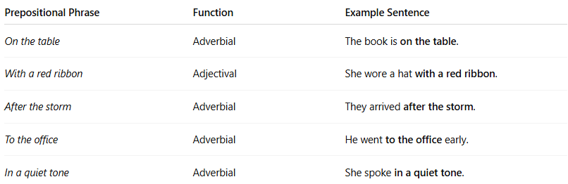

Prepositional Phrase | Function | Example Sentence
On the table | Adverbial | The book is on the table.
With a red ribbon | Adjectival | She wore a hat with a red ribbon.
After the storm | Adverbial | They arrived after the storm.
To the office | Adverbial | He went to the office early.
In a quiet tone | Adverbial | She spoke in a quiet tone.

🧠 Two Main Functions:
# Source: Chatgpt (GPT-4-turbo) at [7/28/2025]
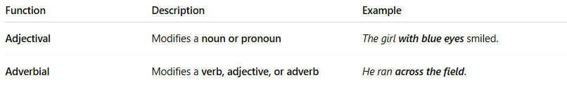

Function | Description | Example
Adjectival | Modifies a noun or pronoun | The girl with blue eyes smiled.
Adverbial | Modifies a verb, adjective, or adverb | He ran across the field.

🔍 Common Prepositions:
# Source: Chatgpt (GPT-4-turbo) at [7/28/2025]
Location/Place:
in, on, at, under, over, behind, beside, near, between
Time:
after, before, during, until, since, at, by
Direction/Movement:
to, into, onto, out of, from
Other Relations:
with, about, of, for, like, without, according to, because of

🧠 Expanded Example:
# Source: Chatgpt (GPT-4-turbo) at [7/28/2025]
Sentence: The keys are under the couch.
- Preposition: under
- Object of preposition: the couch
- Phrase function: Adverbial (modifies “are”) → Where are the keys?

🔄 Comparison with Other Phrases:
# Source: Chatgpt (GPT-4-turbo) at [7/28/2025]
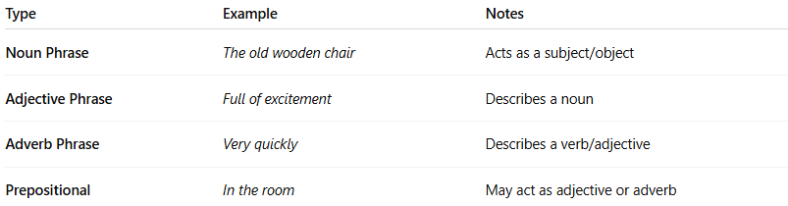
Type | Example | Notes
Noun Phrase | The old wooden chair | Acts as a subject/object
Adjective Phrase | Full of excitement | Describes a noun
Adverb Phrase | Very quickly | Describes a verb/adjective
Prepositional | In the room | May act as adjective or adverb

🧠 Summary Table:
# Source: Chatgpt (GPT-4-turbo) at [7/28/2025]
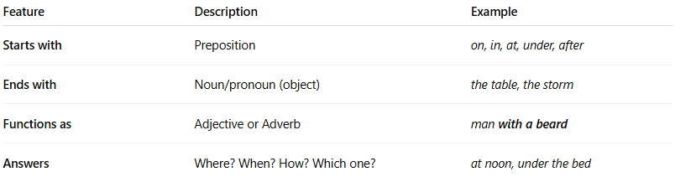

Feature | Description | Example
Starts with | Preposition | on, in, at, under, after
Ends with | Noun/pronoun (object) | the table, the storm
Functions as | Adjective or Adverb | man with a beard
Answers | Where? When? How? Which one? | at noon, under the bed

